**CMP510 (AR and VR Technologies)**

**Assignment 1**



**Navrachana University**

Name: Het Mehta

ID: 22000232

Batch D

Subject: AR VR

**Stoneive:**

To create a basic virtual environment in Unity that includes a ground plane, a skybox, environmental stone, lighting, and simple VR interaction. The player should be able to grab and move the grabbable stone in the environment.

STEPS:

**Task 1: Set Up Your Unity Project & Configure the VR Environment**

• Go to Edit > Project Settings > XR Plugin Management.

• Select the platform and install OpenXR for cross-platform VR support.

• Go to Window > Package Manager> XR Interaction Toolkit> install it.

• Right-click in the Hierarchy and choose XR > Device-based > XR Rig.

**Task 2: Create the Ground Plane**

* Right-click in the Hierarchy> 3D Stone > Terrain.
* Click on the Terrain stone> Inspector panel> Terrain Settings> width = 50 and length= 50.
* In inspector Paint Terrain tool> Set Height= 0
* Go to asset store> different grounds> download> import
* Select Terrain > Paint Texture and assign a ground texture through brush.

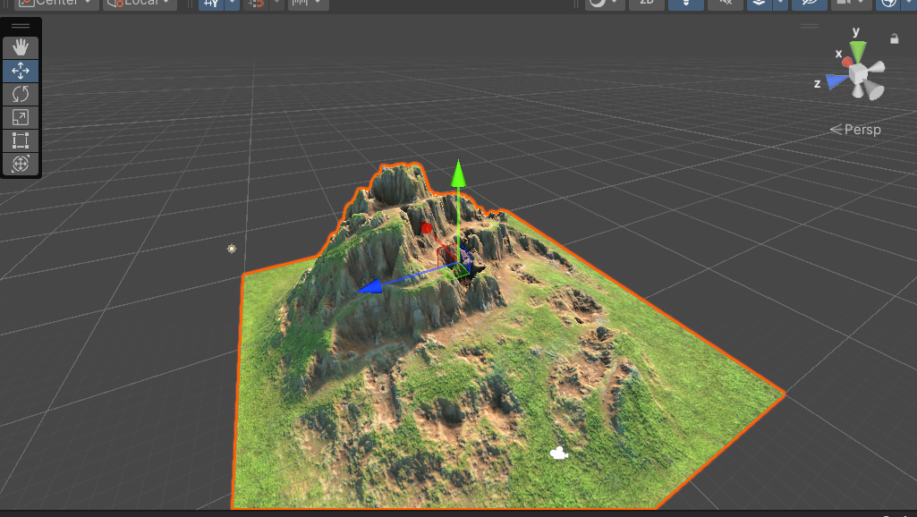

**Task 3: Add a Skybox**

• Go to asset store> sky > download> import

• Go to Window > Rendering > Lighting Settings.

• Enviroment > Skybox Material field> Select sky.

• Scene> Lighting setting as> adjust Sun Intensity.

**Task 4: Add Environment Stone**

• Go to asset store> village and old house> download> import

• Place trees, house, well, gras, shrubs etc in the scene

• Right-click in the Hierarchy> 3D Stone> cube

• Right-click in the Hierarchy> 3D Stone> sphere or any stone

• Position them randomly on the terrain.

• Right-click in the Hierarchy> Create Empty> GrabbableStone> drag 3D stone in it.

**Task 6: Configure Lighting and Shadows**

• Go to GameStone > Light > Directional Light.

• Adjust its rotation to simulate sunlight.

• In the Inspector> Shadow> Soft Shadows.

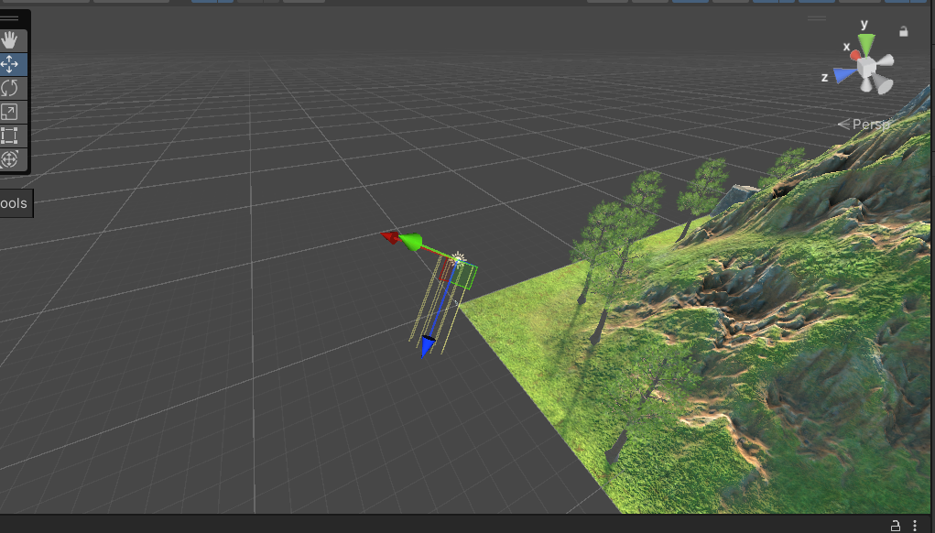

**Task 7: Add Audio**

• Download and save audio in folder.

• Right click in asset> import new asset> custome asset> select the audio.

• Right-click in the Hierarchy> select Audio > Audio Source> Rename it.

• Audio Source> Inspector> AudioClip field> drag audio from asset in it.

• Go to hierarchy place the audio source in the relevant location in scene.

• Test the Audio by playing the scene and moving closer to the audio source.

**Task 7: Add Audio**

* Download and save audio in folder.
* Right click in asset> import new asset> custome asset> select the audio.
* Right-click in the Hierarchy> select Audio > Audio Source> Rename it.
* Audio Source> Inspector> AudioClip field> drag audio from asset in it.
* Go to hierarchy place the audio source in the relevant location in scene.
* Test the Audio by playing the scene and moving closer to the audio source.

**Task 8: Implement Basic VR Interaction**

* Create a Grabbable Stone
* Add Grabbable and Grabber Components
* Select any stone you want to make grabbable.
* In the Inspector window, click Add Component.
* Search for and add the XR Grab Interactable component. This component will allow the stone to be interacted with.
* A Rigidbody component is needed to allow physical interactions
* Go to Add Component and search for Rigidbody.
* Make sure to adjust the Rigidbody settings for smooth interaction.
* Select your hand controllers.
* Add the XR Direct Interactor or XR Ray Interactor component, depending on how you want to grab stone (direct touch or ray-based interaction).
* Ensure that the XR Grab Interactable script on the stone and the XR Interactor script on the hand interact properly.
* Press play in Unity’s Game Mode and use your assigned keyboard buttons (e.g., LSHIFT for right hand, SPACEBAR for left hand) to test if your hands can grab the stone.

Press Play and test grabbing the stone in VR by moving your hands toward them.

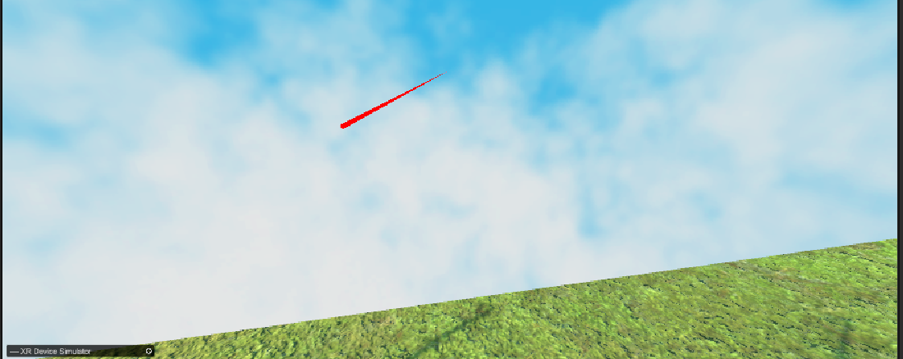

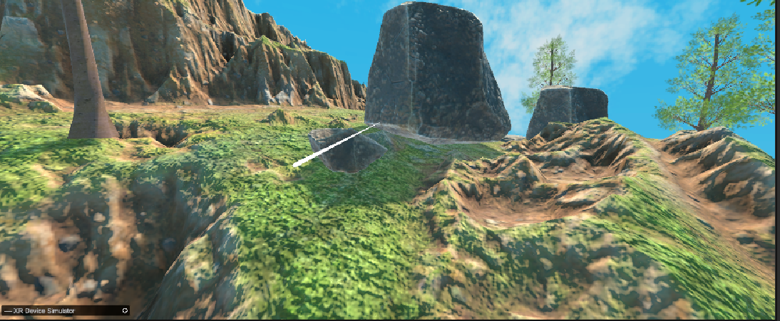

**Task 9: Write the VR Interaction Script**

* Ensure your gem stone have an XR Grab Interactable component from the XR Interaction Toolkit. This will allow them to be grabbed.

**Modify NewBehaviourScript to Work with VR Interactions**

using System.Collections;

using System.Collections.Generic;

using UnityEngine;

using UnityEngine.Events;

using UnityEngine.XR.Interaction.Toolkit;

public class StoneGrabScript : MonoBehaviour

{

[SerializeField] private int numberOfStone;

private int numberOfStoneInSocket = 0;

public UnityEvent unlock;

public void AddStone()

{

numberStoneInSocket += 1;

CheckForAllStone();

}

private void CheckForAllStone()

{

if (numberOfStoneInSocket == numberOfStone)

{

unlock.Invoke();

}

}

public void RemoveStone()

{

numberOfStoneInSocket -= 1;

}

public void OnGrab(XRBaseInteractor interactor)

{

Debug.Log("Stone grabbed by: " + interactor.name);

}

public void OnRelease(XRBaseInteractor interactor)

{

Debug.Log("Stone released by: " + interactor.name);

}

}

Step: 3 Attach VR Interaction Components

* For each Stone, add the XR Grab Interactable component from XR Interaction Toolkit.
* Also, add a Collider (probably a Box or Mesh Collider) and a Rigidbody (set it to Kinematic) so that the stone can be grabbed.
* You can create an XR Socket Interactor where the gems need to be placed.
* When a gem is placed in the socket, it will trigger the AddStone() function.
* Press Play and test the grab/release interaction with the VR controllers.

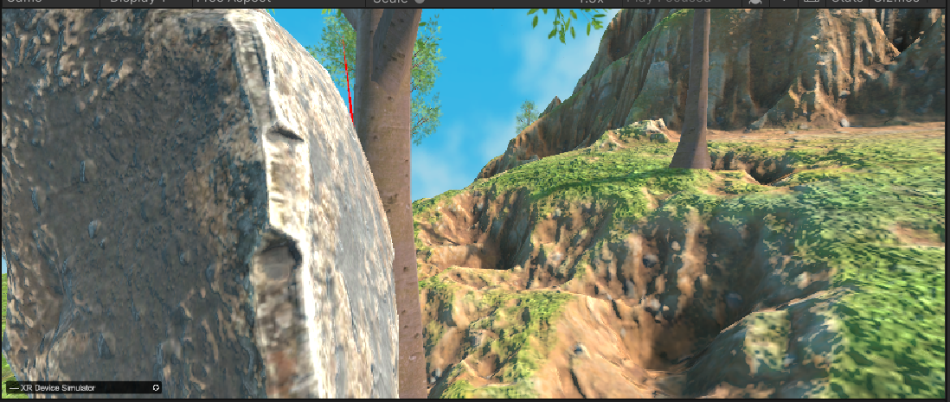

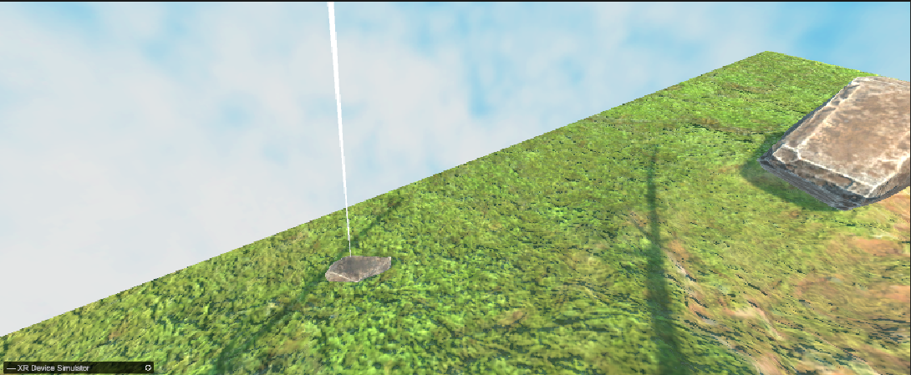

**Task 10: Demo Application**

* Ensure your project runs smoothly by optimizing lighting, reducing unnecessary objects, and lowering the texture size.
* Go to File > Build Settings.
* Select the platform and set the project to VR Supported.
* Run the Application